1. **Declare a class Rectangle having data members length & breadth. Accept and display the area of rectangle for one object**

**CODE:**

class Rect {

int length;

int breadth;

Rect(int length, int breadth) {

this.length = length;

this.breadth = breadth;

}

void area()

{

System.out.print("Area ---> " + length*breadth);

}

}

public class Main {

public static void main(String[] args) {

System.out.println("Abdurrahman Qureshi - 210451");

Rect r = new Rect(20,100);

r.area();

}

}

**OUTPUT:**

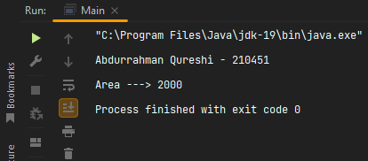

1. **Define a class Factorial with instance variable n and find the factorial of n using recursive method.**

**CODE:**

public class Main{

public static void main(String args[])

{

System.out.println("Abdurrahman Qureshi - 210451");

factor f= new factor(11);

}

}

class factor{

int n;

factor(int n) {

System.out.println("Factorial of 11: "+fact(n)); }

int fact(int n) {

if(n==1)

return 1;

else

return n* fact(n-1);

}}

**OUTPUT:**

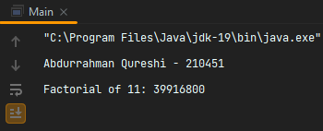

**3) WAP in java to create a class Account having data members as Acc_no, Name and Balance. Accept and display this data for one object.**

**CODE:**

class Account {

int Acc_no;

String Name;

float Balance;

Account(int Acc_no, String Name, float Balance) {

this.Acc_no = Acc_no;

this.Name = Name;

this.Balance = Balance; }

void display(){

System.out.println("Account Number: " + Acc_no);

System.out.println("Account Name: " + Name);

System.out.println("Account Balance: "+ Balance); }}

public class Main {

public static void main(String[] args) {

System.out.println("Abdurrahman Qureshi - 210451");

Account a = new Account(51, "Spectre Scythe", 5100);

a.display();

}}

**OUTPUT:**

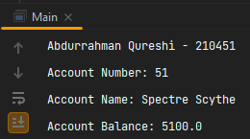

**4) WAP to create a class Book having data members as title, Author and price. Accept and display this data for one object.**

**CODE:**

class Book {

String Title;

String Author;

int Price;

Book(String Title, String Author, int Price) {

this.Title = Title;

this.Author = Author;

this.Price = Price; }

void display(){

System.out.println("Book Title : " + Title);

System.out.println("Book Author : " + Author);

System.out.println("Price of Book : "+ Price); }}

public class Main {

public static void main(String[] args) { System.out.println("Abdurrahman Qureshi - 210451");

Book b = new Book("The Adventures of TinTin","Anonymous",69000);

b.display();}}

**OUTPUT:**

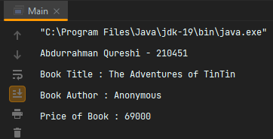

**5) WAP to create a class Employee having data members as Name and Basic Salary. Accept and display this data for one object.**

**CODE:**

class Employee {

String Name;

float Basic_Salary;

Employee(String Name,float Basic_Salary) {

this.Name = Name;

this.Basic_Salary = Basic_Salary; }

void display(){

System.out.println("Employee Name : "+ Name);

System.out.println("Employee Salary :"+ Basic_Salary); }}

public class Main {

public static void main(String[] args) {

System.out.println("Abdurrahman Qureshi - 210451");

Employee e = new Employee("Johnny", 60009);

e.display();

}}

**OUTPUT:**

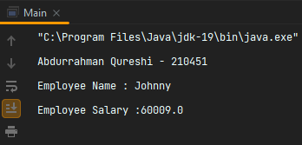

**6) WAP to create a class Person having data members as Name and age. Accept and display this data for one object.**

**CODE:**

class Person {

String name;

int age;

Person(String name, int age) {

this.name = name;

this.age = age; }

void display() {

System.out.println("Name : "+ name);

System.out.println("Age : "+ age); }}

public class Main {

public static void main(String[] args) {

System.out.println("Abdurrahman Qureshi - 210451");

Person p = new Person("Jesse Pinkman",18);

p.display();}}

**OUTPUT:**

